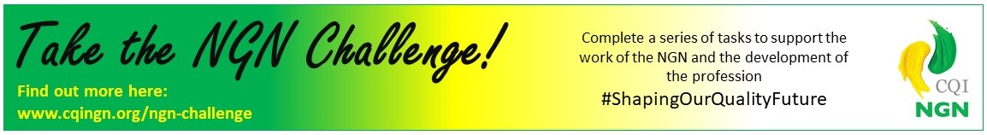
To submit your application for the Gold level NGN challenge award, please complete this form and email it to nextgenerationnetwork@quality.org
Don’t forget to include a photo that you’re happy for us to use on our website!
Name
Job Title
Industry / Company
Short Biography

Gold Challenge Activities
Complete 5 or more of the following activities |  | Link to evidence:
1 | Enable or present at an NGN event
2 | Introduce a friend to the Quality profession through networking
3 | Contact your (or a local) school, college or university and offer to give a talk on your role and profession.
4 | Make contact with another local Young Peoples Networking group to talk about your work in Quality (youth groups, scouts, guides etc)
5 | Contact your local council or politician and talk to them or write to them about the challenges that the quality profession faces
6 | Share the message of the NGN with a colleague from another Professional Membership body
7 | Mentor a Young Quality Professional
8 | Provide an opportunity for the NGN to engage with quality professional communities or networks of young people

Date:
Photo Included:

